### Supplementary Material

**TABLE** **S1** The classification table of LUCC dataset

|  |  |  |  |
| --- | --- | --- | --- |
| G1 (First Grade Level of LUCC) | | G2（Second Grade Level of LUCC） | |
| G1 categories codes | G1 classes | G2categories codes | G2 classes |
| 1 | Agricultural land | 11 | Paddy field |
| 12 | Dry farm |
| 2 | Forestland | 21 | Woodland |
| 22 | Spinney |
| 23 | Open woodland |
| 24 | Other woodland |
| 3 | Meadowland | 31 | High-coverage grassland |
| 32 | Middle-coverage grassland |
| 33 | Low-coverage grassland |
| 4 | Wetland | 41 | Rivers and canals |
| 42 | Lakes |
| 43 | Reservoir pit pond |
| 44 | Swampland |
| 46 | River rapids |
| 5 | Constructive land | 51 | Urban land |
| 52 | Rural residences |
| 53 | Other buildings |
| 6 | Unutilized land | 61 | Desert |
| 62 | Gobi land |
| 63 | Saline-alkali land |
| 64 | Glacier |
| 65 | Bare land |
| 66 | Rocky soil |
| 67 | Other unutilized land |

**TABLE** **S2** The 3 employed LPIs

|  |  |  |  |
| --- | --- | --- | --- |
| Names | Codes | Formulae | Description |
| Shannon`s diversity indicator | SHDI | = $-\sum_{i=1}^{m}{(p_{i}*lnp_{i})}$ | SHDI is a measure of patch classes diversity in landscape (Nagendra, 2002), $p_{i}$ is the proportion of the landscape occupied by patch class i. |
| Patch richness indicator | PR | =m | PR is the meaning of the number of patch classes (Baldwin et al., 2004), m is the number of different landscape patch classes. |
| Number of patches indicator | NP | = $\sum_{i=1}^{m}{{np}_{i}}$ | NP is the total number of patches in the landscape(Cain et al., 1997), ${np}_{i}$ is the number of patches within path class i. |

**TABLE S3** Calculation formulae of the FLIs

|  |  |  |  |
| --- | --- | --- | --- |
| Names | Codes | Formulae | Comments |
| Fusion Shannon’s diversity indicator | FLI-SHDI | = $-\sum_{i=1}^{m}{(p_{i}*lnp_{i}*(1-(p_{i}*\sum_{j=1}^{n}{\left(p_{ij}*\ln\left(p_{ij}\right)\right)}/\ln\left(n_{i}\right)))}$ | $p_{i}$ is the proportion of the landscape occupied by patch class i; $p_{ij}$ is the proportion of the second-grade level patch class j in the first-grade level patch class i ; and $n_{i}$ is the number of second-grade level landscape classes occupied by the first-grade level. |
| Fusion path richness indicator | FLI-PR | = $\sum_{i=1}^{m}{({pr}_{i}*(1-(p_{i}*\sum_{j=1}^{n}{\left(p_{ij}*\ln\left(p_{ij}\right)\right)}/\ln\left(n_{i}\right)))}$ | If the landscape region contains first-grade level patch class i; then ${pr}_{i}$ equals 1; else ${pr}_{i}$ equals 0. |
| Fusion number of patches indicator | FLI-NP | = $\sum_{i=1}^{m}{({np}_{i}*(1-(p_{i}*\sum_{j=1}^{n}{\left(p_{ij}*\ln\left(p_{ij}\right)\right)}/\ln\left(n_{i}\right)))}$ | ${np}_{i}$ is the number of patches of the first-grade level path class i. |

FLI-SHDI is a Shannon’s diversity indicator based on two-grade patch classes, whose value represents the amount of information entropy per G1 patch class and G2 path class. FLI-PR measures the richness or richness density of two-grade patch classes, which are not affected by the spatial arrangement of landscape patterns. And FLI-NP measures the number of patches or patch density, which fuse G1 and G2 patch classes.

**TABLE S4** The relationship between the LPIs and their corresponding information volumes across 3 indicators (using the spatial matching Pearson correlation coefficient method, Fig. S1)

|  |  |  |  |
| --- | --- | --- | --- |
| Types | SHDI | PR | NP |
| FLIs, Information volume of FLIs | -0.19* | -0.34** | 0.26** |
| G1LIs, Information volume of G1LIs | -0.10 | -0.39** | 0.23* |
| G2LIs, Information volume of G2LIs | -0.27* | -0.08 | 0.32** |

Notes: * means correlation significant at the 0.05 level, ** means correlation significant at the 0.01 level.

**TABLE S5** The multiple linear regression equations of information volume for SHDI, PR, and NP

|  |  |  |  |  |
| --- | --- | --- | --- | --- |
| Types | Multiple linear regression equations | R2 | F value | P value |
| SHDI | |  | | --- | | Y= -0.11+0.75×X1+0.27×X2 | | 0.92 | 5724.01 | <0.001 |
| PR | |  | | --- | | Y= 4.32+0.71×X1+0.23×X2 | | 0.55 | 600.97 | <0.001 |
| NP | |  | | --- | | Y= 1.01+0.90×X1+0.14×X2 | | 0.94 | 8102.19 | <0.001 |

Notes: The confidence level is set to 99%, Y is the information volume of FLIs, X1 is the information volume of G1LIs, and X2 is the information volume of G2LIs

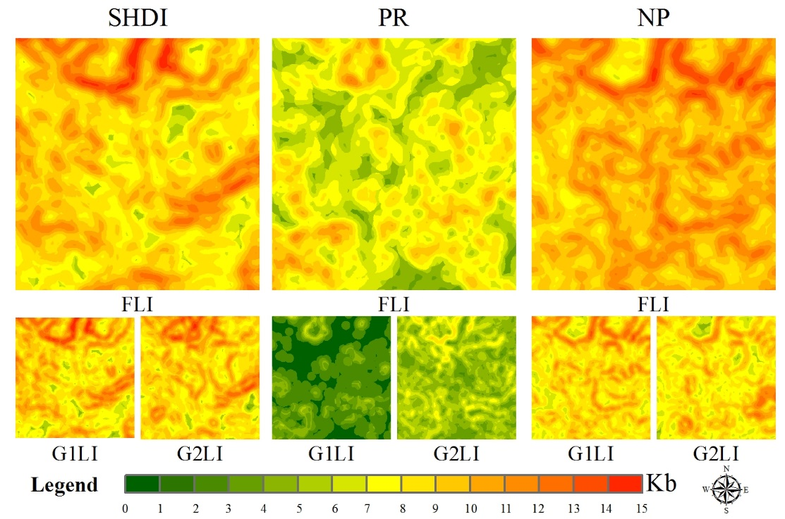

**FIGURE S1** The spatial distributions of information volume of the FLIs, G1LIs and G2LIs / KB (KB is 210 bits)

**References:**

Baldwin, D.J.B., Weaver, K., Schnekenburger, F., and Perera, A.H. (2004). Sensitivity of landscape pattern indices to input data characteristics on real landscapes: Implications for their use in natural disturbance emulation. Landscape Ecology, 19, 255-271. https://doi:10.1023/B:LAND. 0000030442.96122.ef.

Cain, D.H., Riitters, K., and Orvis, K.,1997. A multi-scale analysis of landscape statistics. Landscape Ecology, 12, 199-212. https://doi:10.1023/A:1007938619068.

Cushman, S.A., McGarigal, K., and Neel, M.C.,2008. Parsimony in landscape metrics: Strength, universality, and consistency. Ecological Indicators, 8, 691-703. https://doi.org/10.1016/ j.ecolind.2007.12.002.

Nagendra, H.,2002. Opposite trends in response for the Shannon and Simpson indices of landscape diversity. Applied Geography, 22, 175-186. https://doi.org/10.1016/S0143-6228(02)00002-4.